**Assignment Five: Lo-fi Prototype and Test**

**The Team:**

Eli V., Jake R., Fiona H.Z., David R.B.



**ConverStation**

Stop here for something new!

**Introduction**

**Value Proposition**

Meet new people, find new perspectives!

**Mission Statement**

Our goal is to introduce users to new people and encourage discussion in a way that fits into their everyday lives.

**Problem/Solution Overview**

Every day we are surrounded by people with a variety of backgrounds, interests, and life stories. We could learn so much from talking to these people, but we find it awkward to start a conversation with a stranger, especially if we’re unsure if they’re busy. ConverStation connects users who are available and in the same immediate area, prompting them to start a conversation and learn from someone they might otherwise have passed right by.

**Rough Sketches**

Before this week, we assumed our solution would be a mobile app, so we made a point of trying to explore as many modalities as possible to challenge the assumptions we were making.

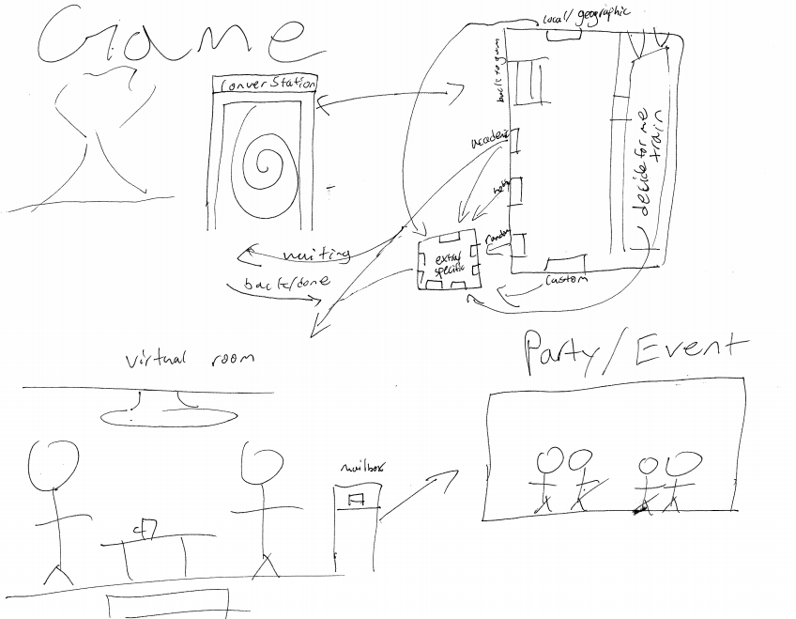

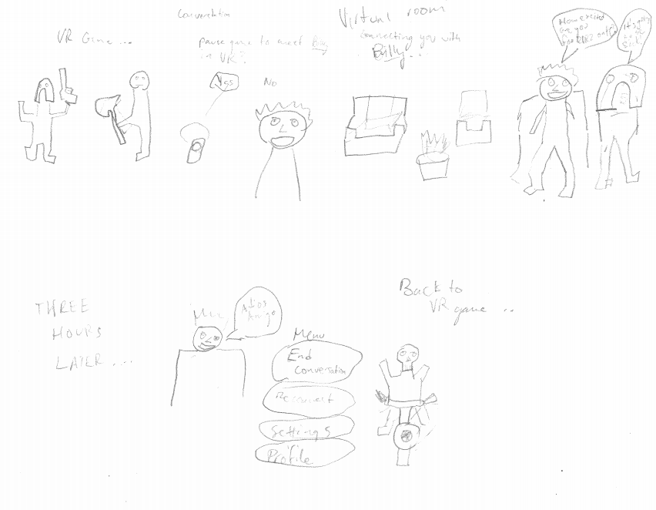

**VR**

Our VR implementation would match users with conversation partners and notify them while they’re playing VR games so they can take a conversation break. While this did meet our goal of fitting conversation into everyday life, we preferred the idea of face to face interaction.

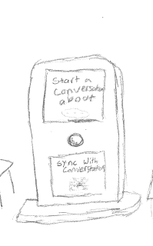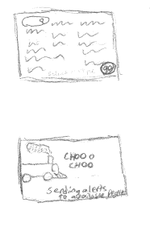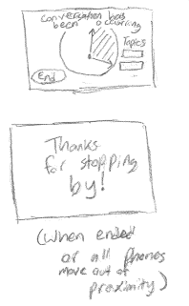

**Booths**

Our next implementation featured physical ConverStation booths at set locations which would pair with the user’s phone. We liked the idea of basing the app around set locations, but felt that the physical booth was an unnecessary middleman.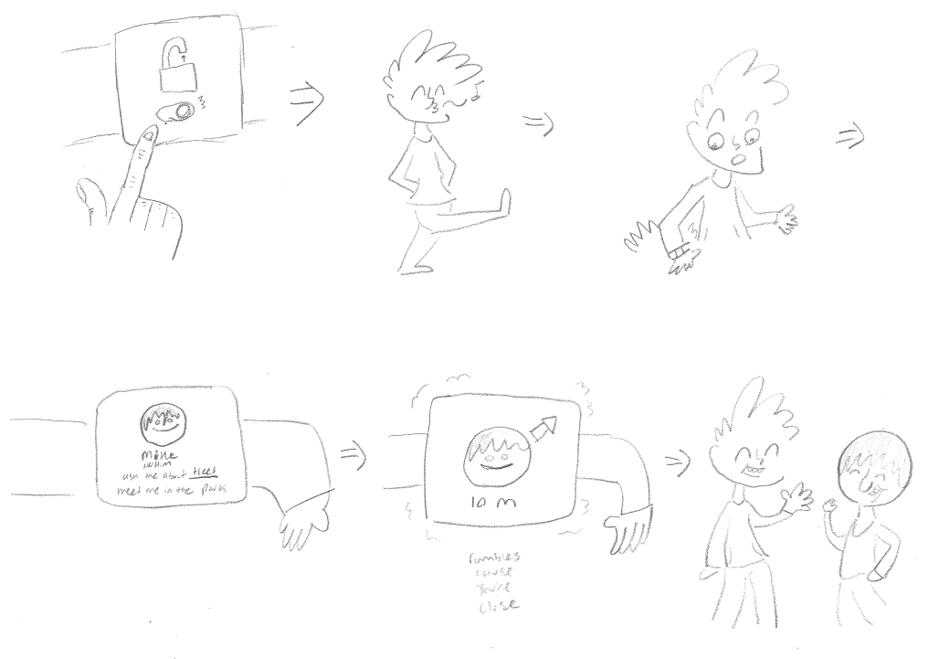

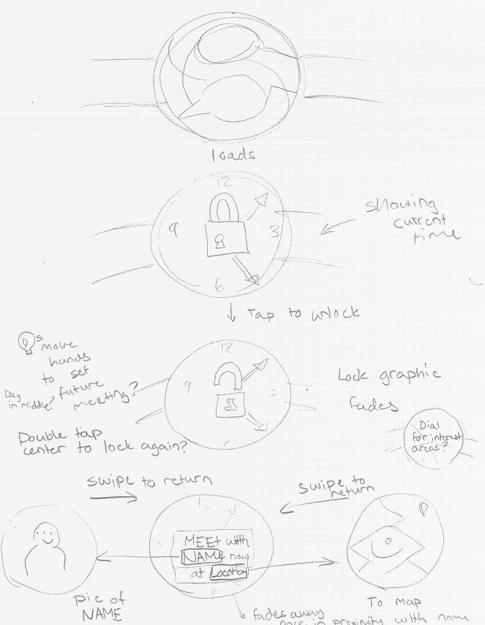

**Smartwatch**

The smartwatch implementation emphasizes quick, simple interactions so that the user can focus on their conversation. They just need to flip the availability switch and the watch will notify them when it finds a partner.

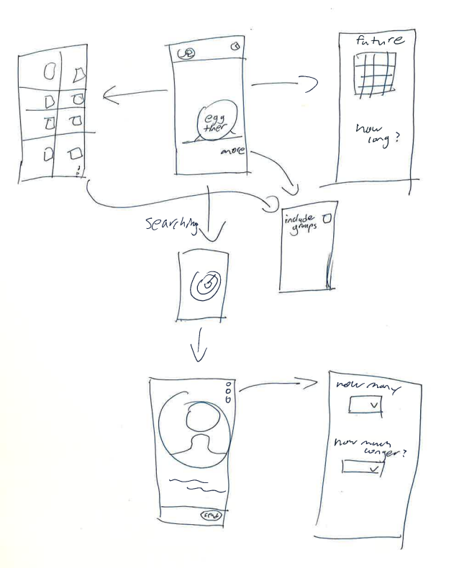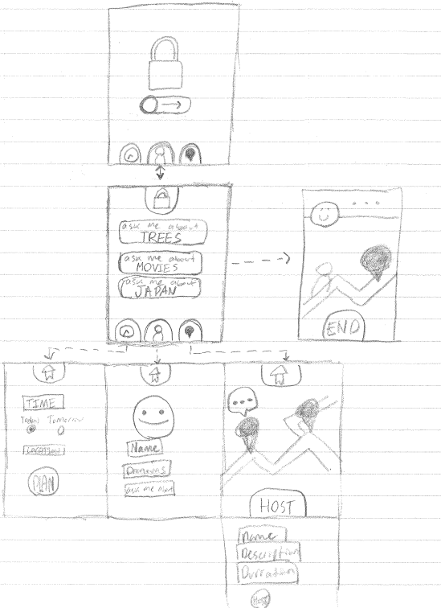

**Toggle-based (Smartphone)**

The first smartphone implementation is similar to the smartwatch in that the user toggles a switch to indicate they’re available, but it also takes advantage of the phone’s larger interface to let the user pick conversation topics from nearby users that they’re interested in.

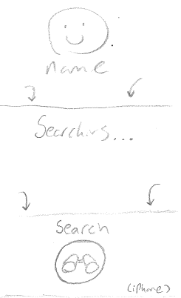 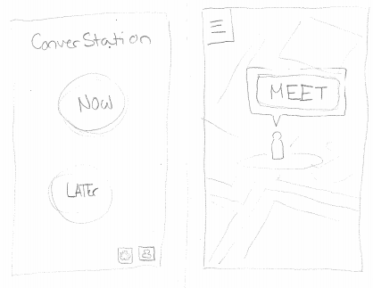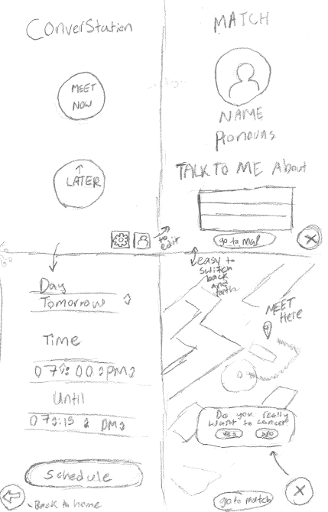

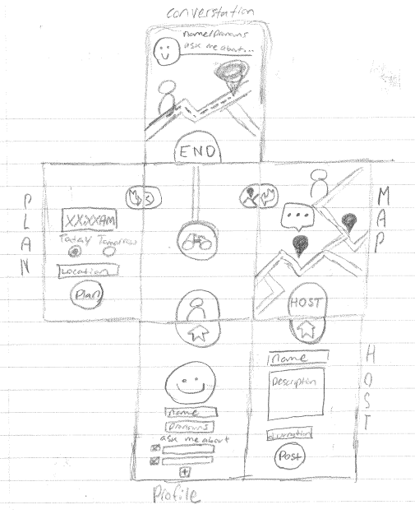

**Button-based (Smartphone)**

This second smartphone implementation features a simple button the user can press to find a conversation. Unlike the toggle, the user is locked into finding a partner once they’ve pressed the button. This streamlines the process, so they don’t get lost in the interface.

**Storyboards**

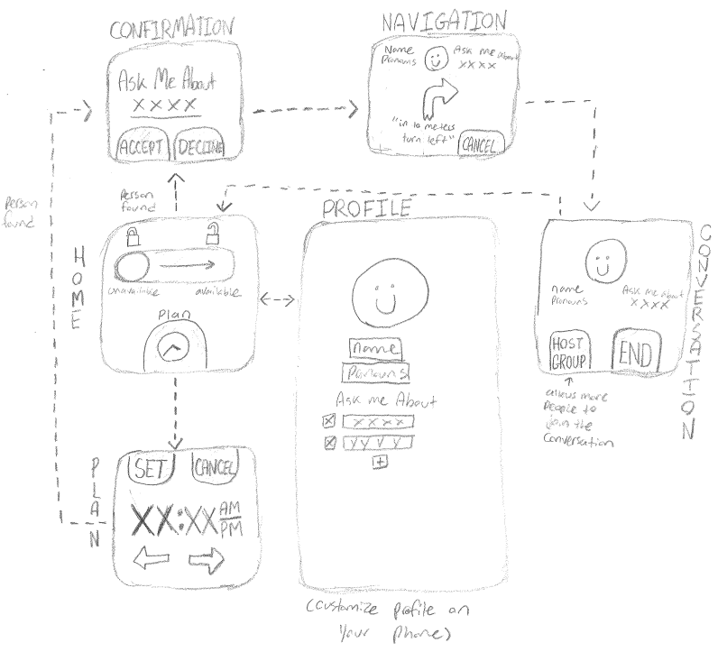

**Smartwatch storyboard**

We picked the smartwatch as one of our storyboards because it matched our theme of fitting conversations into everyday life. Because smartwatch interfaces are limited, we made the design as simple as possible.

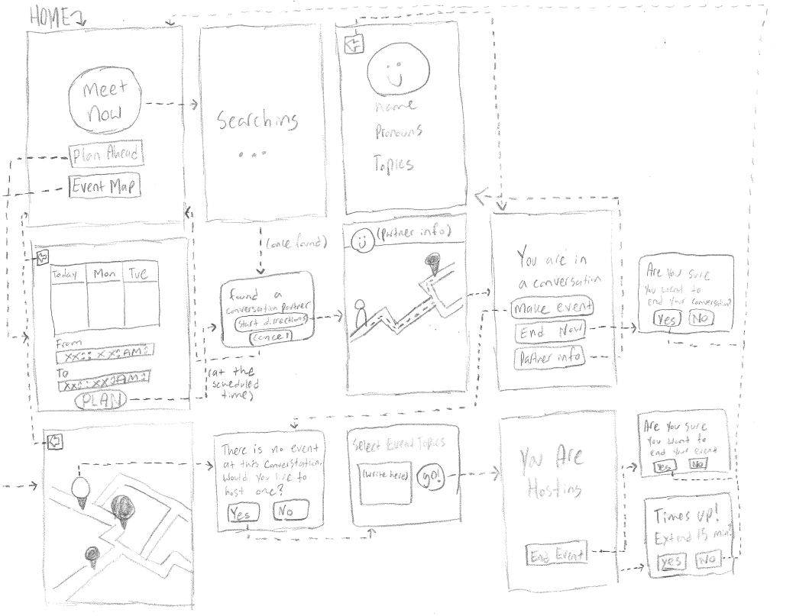

**Smartphone storyboard**

We picked the button interface over the toggle interface for the phone, since it was more streamlined. The user simply presses the “meet now” button on the home screen to get automatically paired with a conversation partner. A planning calendar, event map, and profile editor are implemented as side menus. We took inspiration from the physical booths idea and made meetups and events take place at fixed “ConverStation” points.

**Selected Interface Design**

**Smartwatch**

**PROS**

* Simple to navigate
* Doesn’t distract from the conversation

**CONS**

* Can’t set events directly, need to already be in a conversation
* Plan for only one future time
* Need a phone to enter the user profile
* Step-by-step instructions instead of map directions

**Smartphone**

**PROS**

* Start events from an existing conversation or directly from the event map
* Can plan ahead for multiple times in the coming days
* Button interface prevents the user from getting lost
* Detailed map screen for navigation and event finding

**CONS**

* Phones potentially distracting from the conversation

**Decision**

While the smartwatch was simple to interact with and fit better into everyday life, the amount of additional features made possible by the smartphone’s more precise display made it more desirable. Moreover, since the user cannot edit their profile on a smartwatch, we would need a companion smartphone app for that purpose anyway. Therefore, we decided to move forward with the smartphone implementation.

**Task Storyboard**

**Task 1: Meet**

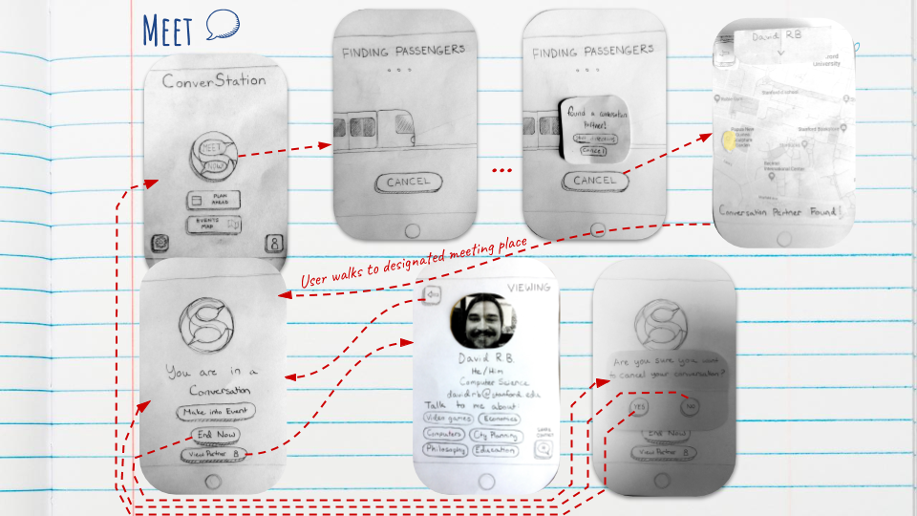

**Task 2: Plan**

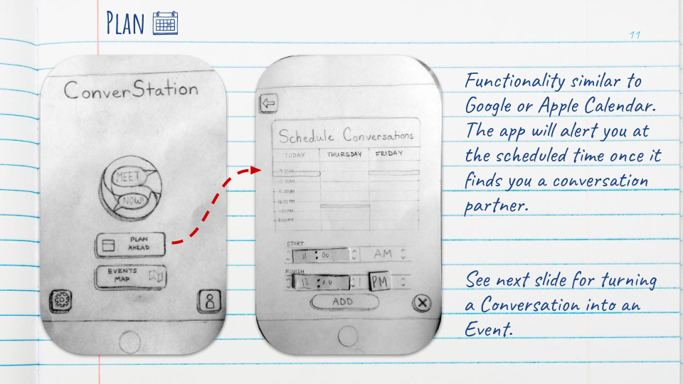

**Task 3: Event**

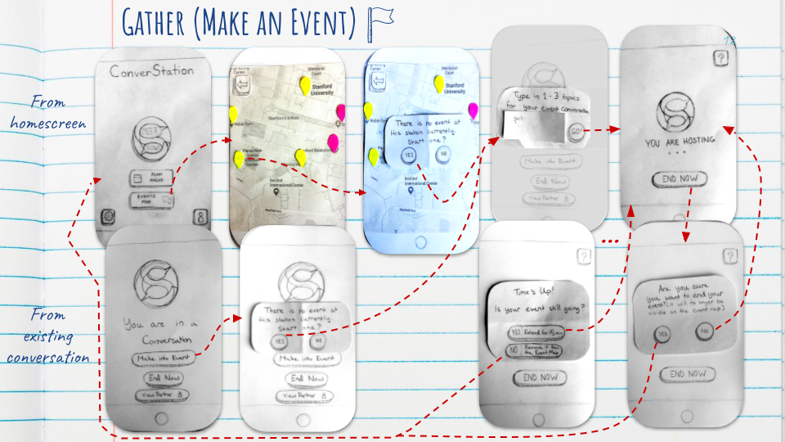

**Prototype Details**

|  |  |  |
| --- | --- | --- |
| **Home Screen** |  | Landing and hub |
| **Searching** |  | Waiting to be matched |
| **Directions** |  | Directions to the ConverStation where the user will meet their partner |
| **Conversation** |  | The user is in a 1-on-1 conversation. |
| **Partner Info** |  | Conversation partner’s profile |
| **Planner** |  | The user can indicate free time for automatic matching |
| **Event Map** |  | User can see which ConverStations have events going (red) on and which are open (yellow), and start an event by tapping on the ConverStation icon which they are physically near to. |
| **Event Hosting** |  | The user is hosting a group event |

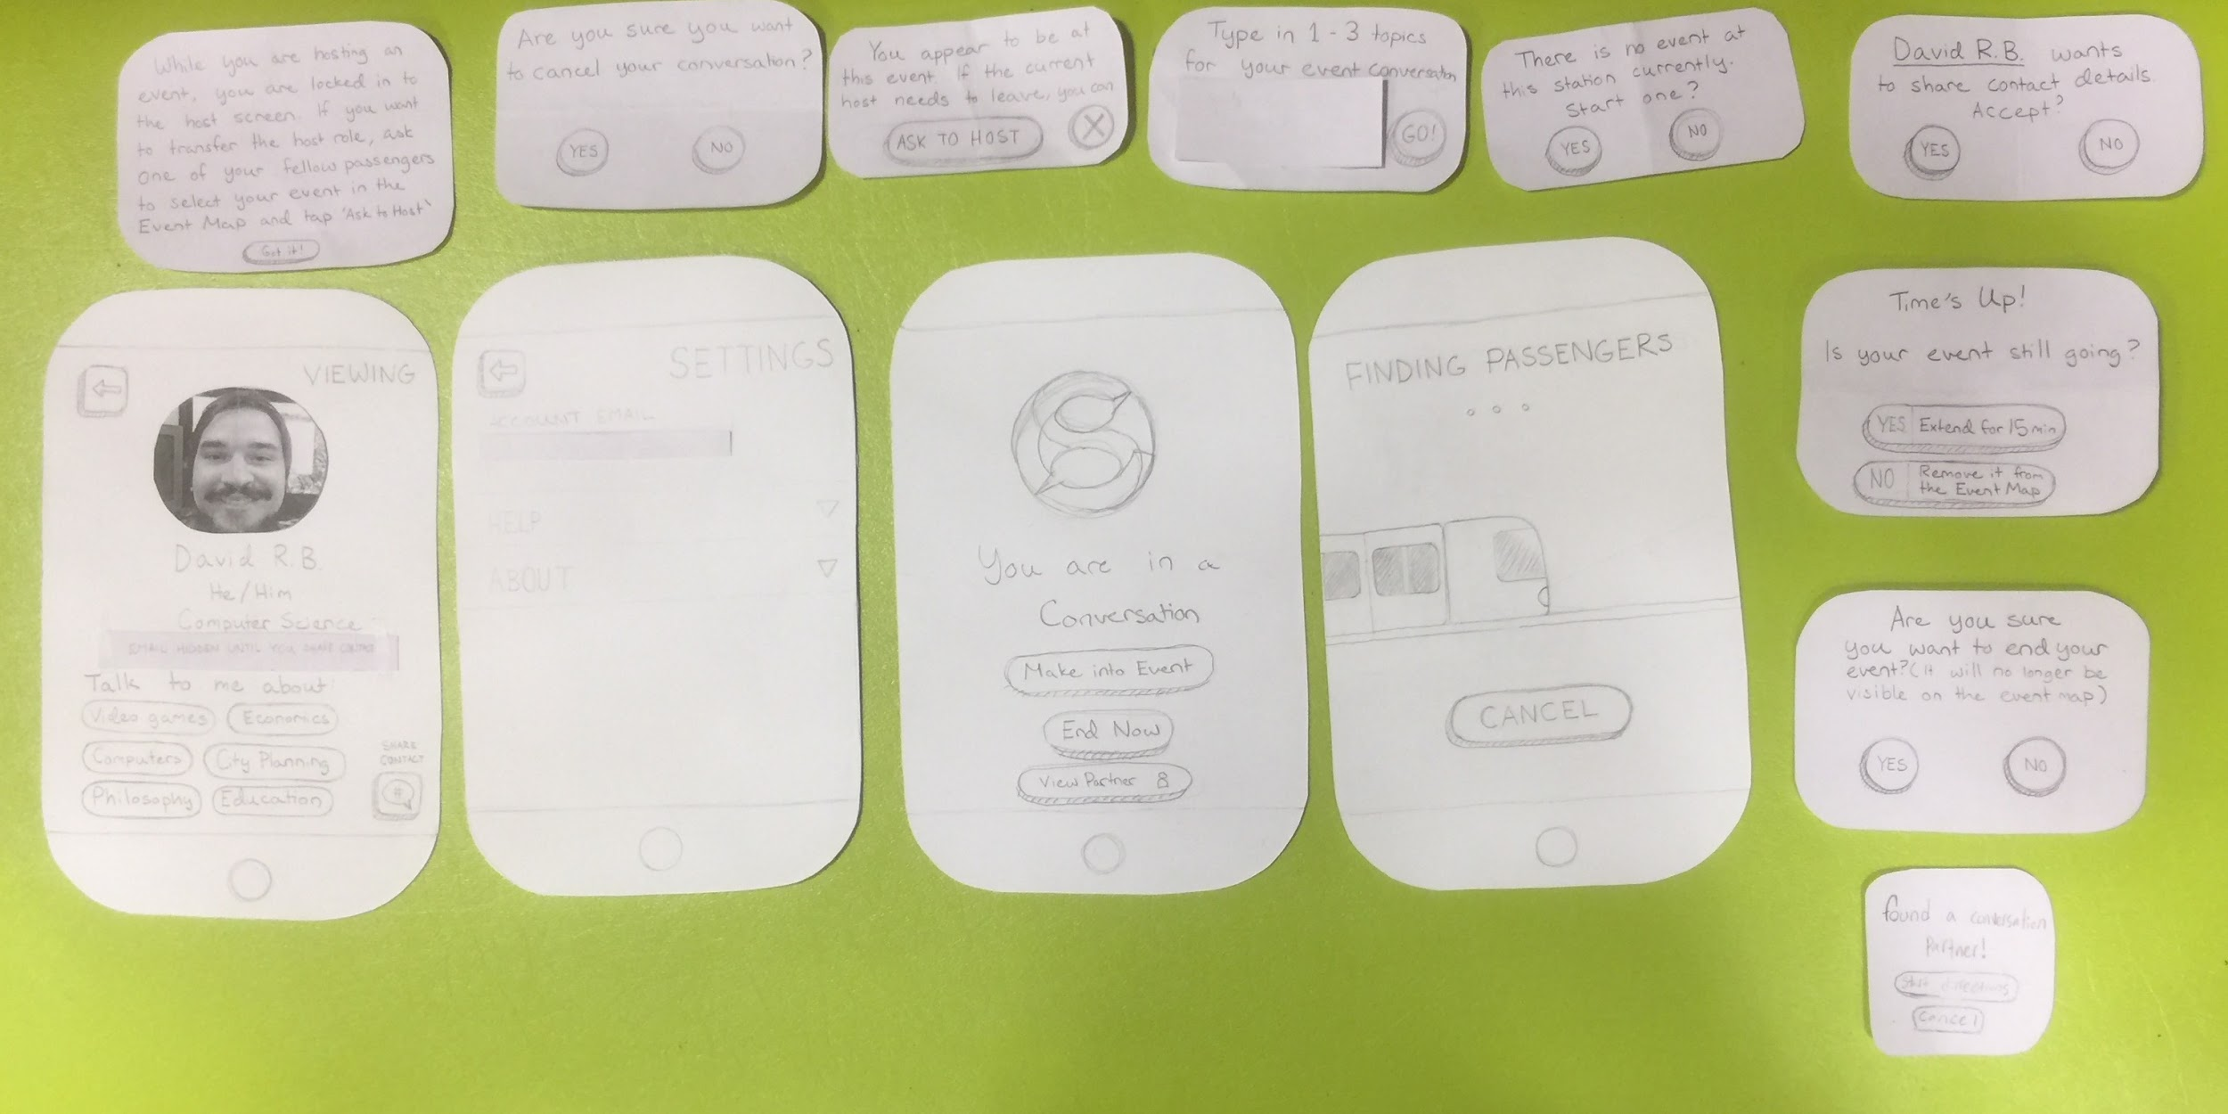

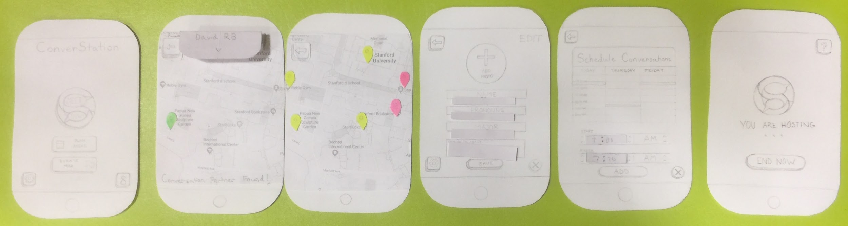

All prototype pieces. Includes popups and a few screens not used in the tests.

**Methods**

**Participants**

Our tests included 3 participants: two stanford students and a visitor to campus in his 30s. No compensation was offered.

**Environment**

The two student tests were done in the Roble maker space at around 5:00pm. The other test was done in Tresidder around 7:00pm.

**Tasks**

In addition to testing our 3 tasks, we wanted the participants to perform additional subtasks such as turning a conversation into an event and extending events for 15 minutes in order to test the robustness of our interface. Here is the task list we provided to our participants:

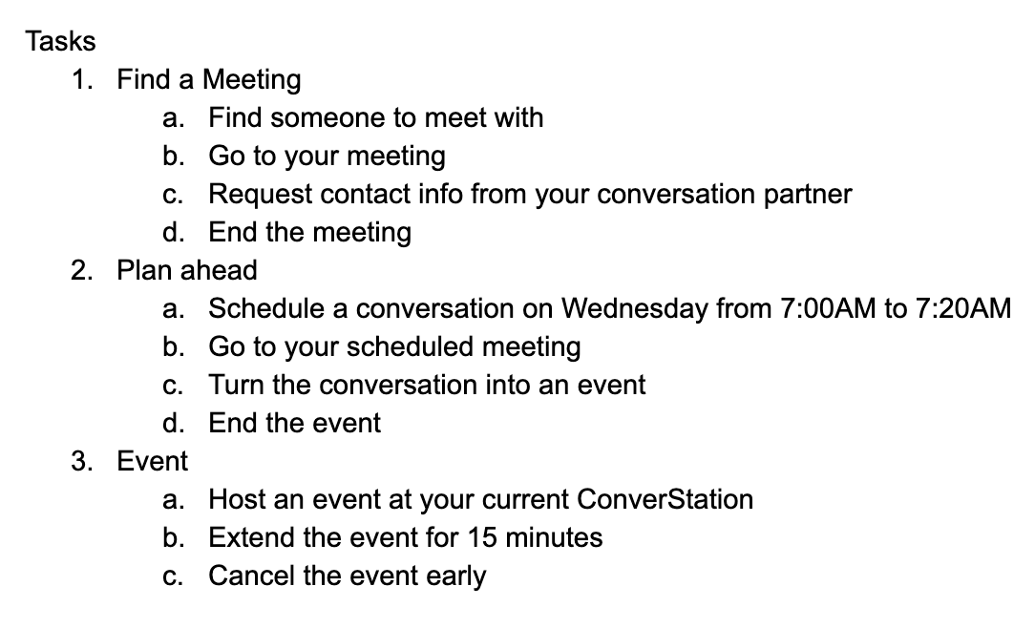

**Procedure**

For our test, we did not actually have the users get up and go to a location or talk to a conversation partner. Instead, we only asked participants to navigate the interface. Our procedures were as follows:

1. Greet participant and explain the purpose of the app
2. Give participant task list and begin the prototype test
3. Explain events that would happen outside of the app during real usage
4. Indicate if participant thought they had accomplished a task when they had not; ask them to try again
5. Debrief with an interview

**Task Measures**

While testing, we were particularly interested in observing

* Frequency and severity of errors made
* Interface ease of use and intuitiveness
* Understanding of each task’s purpose

**Team Member Roles**

* Fiona: Prototype Artist
* Eli: Greeter/Facilitator
* Jake: Computer
* David: Observer/Interviewer

**Results**

* All participants correctly tapped “Meet Now” to start a meeting as their first tap.
  + 1 participant hesitated, thinking it might be a logo.
* All participants were confused by exterior events which had to be described to them (i.e. walking to a new location, time passing, etc).
* All participants found the UI for finding a meeting and planning ahead straightforward.
* No trouble understanding how to turn an existing conversation into an event.
  + 2 participants found it easier to find a new conversation and turn that into an event rather than figure out how to host one from the event map for task 3
* All participants had trouble understanding how to host an event from the event map.
  + Only 1 participant figured it out eventually. 1 participant went to the screen but didn’t try tapping the location markers. The other never visited the screen.
* All participants were confused about what an “event” is when instructed to host one.
  + 1 participant remained confused after the test was complete.

**Discussion**

The results from these tests were promising overall. The UI for meetup and planning were straightforward and intuitive. Most of the confusion found in these tasks came from the simulated external events, which won’t be a problem in future prototypes. However, participants were consistently confused about the directions screen. There may not be enough indication of the screen’s purpose. A prompt, such as “navigating to your meeting place”, could make the screen’s purpose clearer.

The most errors occurred in starting events. While users understood how to turn an existing conversation into an event thanks to the obvious button prompt, they had trouble understanding how to do the same from the event map. This could be improved with better labeling and prompts to inform the user that they *can* host events on the event map. There was also a problem of terminology; users were not sure what an “event” was or why they would want to host one. Calling them “group conversations” would make their function more apparent.

Another source of confusion was the purpose of the app. All of the users were confused when the app was first described to them, although they seemed to understand it better as they performed the tasks. Some way of making the purpose clearer to the user upfront could alleviate confusion. After the tests, 2 of the 3 participants said they would like to use the app. These two expressed that they would like to use it to talk to others about their interests specifically. For instance, the older participant said he would like to use it to meet Stanford students and discuss CS with them. These answers reinforce that we should find a way to pair users based on shared interests.

Word Count: 1442

**Appendix**

**Blank Consent Form**

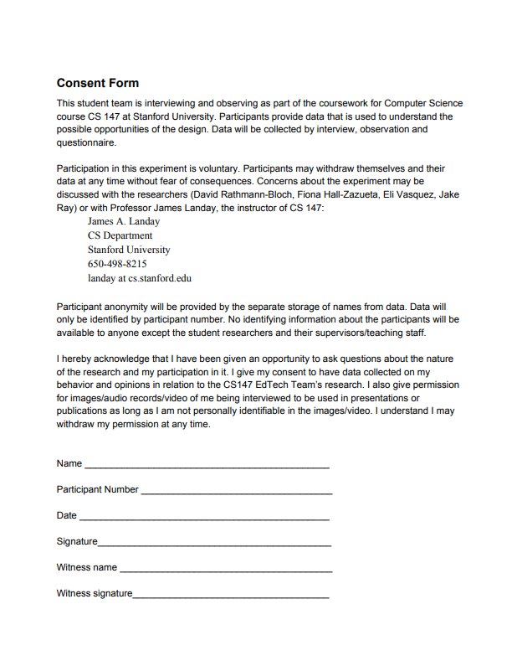

**Prototype Raw Data (participant names are pseudonyms)**

**Participant 18 “Juanita” (stanford student)**

Immediately clicked meet now for task 1

Got that “finding passengers” was loading

Had trouble finding out where to request contact info; This might be more emphasized

Found plan ahead easily, etc.

Calendar was harder, largely because the context was a bit rougher on paper

Make an Event was quick

Decided to end the event after time passed.

Task 3 showed more hesitation. It seemed like starting the event from an existing conversation was more intuitive. We need to say where you can start event.

**LOG:**

Issues:

2 = She wanted to request contact info directly from the conversation screen; going to profile was not intuitive.

1=calendar should be more fleshed out (and it’s an area for detail in the future)

3=start event was very unintuitive from event map. We need more UI elements that make it obvious how to start vs. join an event (rather than turning a conversation into an event, which was much more intuitive)

Positives:

2 = really liked overall look of main screen

3 = had an easy time setting up meeting

1 = would use app in the future

2 = enjoyed making conversation into event

1 = perceived overall UI design as clean, did not want more or less control overall

**Participant 19 “George” (stanford student, turned out to someone also taking CS147)**

Also immediately clicked meet now for task 1

Had an easy time getting into conversation.

Intuitively understood the design.

Hosted event quickly

Liked the help icon in event

Overall relatively quiet while using the app

Didn’t have any issue with requesting contact details.

Also confused by the event map, but intuited the correct way of interacting

Colors should match throughout the app! (I.e., event in progress should always be green, free venue always yellow).

**LOG**

Issues:

2 = slightly confused by event map, wanted more intuitive color scheme

3 = noticed inconsistency in overall application UI

1 = He felt that “Finding Passengers” doesn’t really fit with theme

Positives:

3 = liked the experience of using the app to start conversation

2 = when asked to make conversation into event, had an easy time of setting that up

**Participant 20 “Sid”. (Adult, non-stanford student. Doesn’t use a lot of phone apps.)**

Didn’t immediately see that “meet now” was a button--thought it might be a logo

Paper prototype idea was overall confusing, he found it odd to be tapping paper

Very methodical and logical in trying to figure out how the UI works.

Didn’t immediately see the back button to end the meeting; got a bit confused by the task here

Task 2 started out a good amount smoother.

Calendar was clear and he seemed to enjoy it

Found it a bit confusing that we hadn’t fully fleshed out the map/directions.

Making conversation into event went really smoothly.

Timing for paper prototype wasn’t clear -- e.g., that 15 minutes pass before the event extension prompt

Canceling and setting up the event was quick and seemed fun

**LOG**

Issues:

3 = felt a significant lack of control and information on the app; didn’t just randomly want to meet strangers without seeing a profile first

2 = Was not confident that he would easily accomplish tasks without instructions

Positives:

3 = Thought UI was very intuitive overall

2 = Liked the taskflow from conversation to event

1 = Appreciated aesthetic design elements like the logo and the train

**Interview Questions/Answers**

1. How did you feel about the UI experience overall?
2. Were there times when the interface confused you?
3. If you could change any aspect of the interface, what would you change?
4. Would you use an app like this if it were available for free?
5. Are there areas where you wanted more or less control in the app?
6. Did you feel there were surprises in using the app?
7. Can you give an example of an app, computer program, etc., with a UI you like?
8. Can you give an example of an app, computer program, etc., with a UI you don’t like?
9. Which of the 3 activities was easiest/hardest?
10. Any other comments?

18:

1. Clean and clear overall; one confusing part at the end (thought event map was already created events.
2. Sharing/requesting contact info could have been clearer
3. For the event map, she recommends a button to create a new event, or “click a location to create an event”. For the request, she would change the task wording on the sheet.
4. Probably when bored, she would use it. She would talk about things she’s interested in (e.g., minecraft). Not used for educational types of things, more social.
5. Not really
6. Nothing surprising, but didn’t really understand the difference between event/conversation. Would like a description with the beginner tutorial when first downloading the app.
7. YouTube (mobile, iPhone)
8. TikTok is so confusing.
9. Easiest was making a conversation (meet up) more confusing was making an event.
10. Not really,

19:

1. Good experience “I thought the UI was really intuitive for the most part”. Overall app comment--you know when like pokemon go is used to commit crimes, this is a potential problem.
2. No… the only thing I’d say is I’m unlikely to look at a screen when I’m in a conversation, but I still get why you have that there
3. (Pauses a long time) I guess “finding passengers” doesn’t really align with the rest of it as a loading screen. Seems tangential since app is not that transportation based.
4. Probably not. But I think it’s mostly that going up to someone would be outside comfort zone
5. Just within the directions, have a route (we plan to do that). More cancellation options, or previewing the profile to see if you have shared interests.
6. THe “you are in a conversation screen” was a bit odd

20:

1. Had trouble understanding the overall--what he was trying to do. But the tasks were very straightforward. Menu labels and buttons were intuitive. Still didn’t quite get the map part But that may be a part of the app itself. Thinks it was intuitive.
2. Aside from the map, he would have liked to explore the event map. Would have liked to know beforehand what the app is trying to accomplish. Task list made it much easier tan it would be in real life. He doesn’t really know who is available, how invitations worles. Might have preferred to have set his state as available. Would have liked a choice of people, not just an automatic button. Or more control in that area.
3. Other than before, he thought it was good; he could do the task
4. He would use the app, but he’d appreciate more idea of what is he getting into/more information. Topics he might find interesting: software engineering. But it might be awkward if he had a conversation partner who wanted to talk about music, since he’s not that into music.

6) No, the tasks were pretty clear and corresponded well with the screens.

7-8) Likes ones which don’t do a lot of choices -- e.g., FaceTime (one button to connect); doesn’t like apps that don’t show him all the options available. He thought the shake to undo function was a cool UI element in Apple Mail.

9) they were all very intuitive, there wasn’t one that was hard. Would have been much harder without the written task guidelines.

**Additional Sketches**

